**AddAADGroupOwnerTimespand (FLOW & POWERAPP)**

API Permissions needed: **Group.ReadWrite.All and User.Read.All**

# The FLOW:

Update the 2 flows:

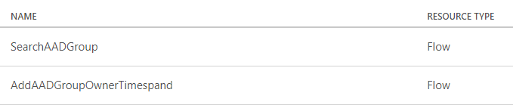

Import the Flow packed and change the values:

